**Math 120  
1.5 More on Slope**

**Objectives:**

1. Find slopes and equations of parallel and perpendicular lines.

2. Interpret slope as rate of change.

3. Find a function’s average rate of change.

4. Find and simplify a function’s difference quotient.

# Topic #1: Parallel Lines

*Parallel Lines:* Two lines that do not meet in the plane are **parallel**. The graph below shows Line 1 with slope and Line 2 with slope . The graph indicates that parallel lines have the **___________________** We will limit our focus to non-vertical lines (although all vertical lines are parallel).



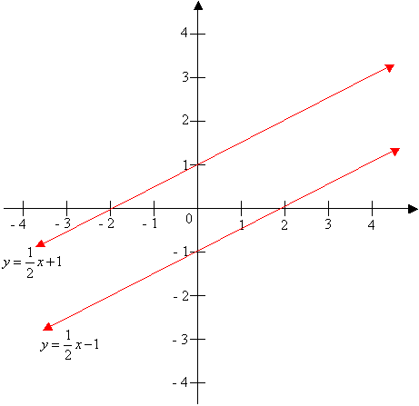

If 2 lines are parallel, then .

*Example #1* – Find the Equation of the Line with the Given Conditions

a) Find the line parallel to the line that passes through the point . Write in slope-intercept form.



Plug into the point-slope equation and solve for to write in slope-intercept form:

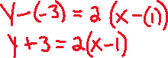

Entering Y1=2x and Y2= on your graphing calculator, you can confirm that the lines are parallel.



b) Find the line parallel to the line that passes through the point . Write in slope-intercept form.

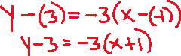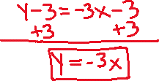

You can enter the two equations into your graphing calculator to confirm the lines are parallel.

c) Find the line parallel to the line that passes through the point .

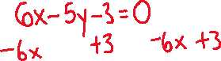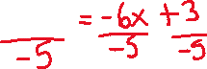

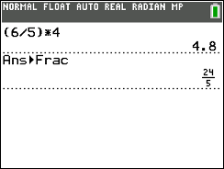

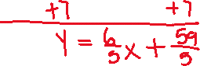

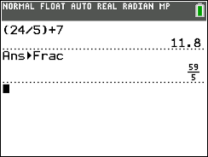

*YOU TRY #1* - Find the line parallel to the line that passes through the point . Write in slope-intercept form. Enter the two equations into your graphing calculator to confirm the lines are parallel.

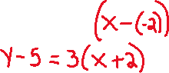

# Topic #2: Perpendicular Lines

*Perpendicular Lines:* Two lines that meet in the plane at a 90-degree angle are **_______________________** The graph below shows Line 1 with slope and Line 2 with slope . The graph indicates that perpendicular lines have **SLOPES** that are **__________________________** We will limit our focus to non-vertical and non-horizontal lines (although all vertical lines are perpendicular to all horizontal lines).



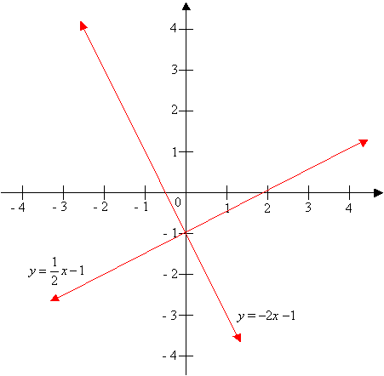



**; in words this means the product of the slope of perpendicular lines equals -1.**

*Example #1* – Find the Equation of the Line with the Given Conditions

a) Find the line perpendicular to the line that passes through the point . Write in slope-intercept form.



Plug into the point-slope equation and solve for :

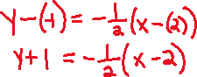

You can graph the 2 equations on your calculator to check the lines are perpendicular.

*YOU TRY #2* - Find the line perpendicular to the line that passes through the point . Write in slope-intercept form.



Plug into the point-slope equation and solve for y:

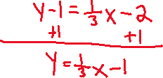

# Topic #3: Slope as a Rate of Change

Slope is defined as the change in over the change in . When and represent quantities, the slope becomes a **_________________________________** The graph shows the remaining life expectancy in years for females of age .



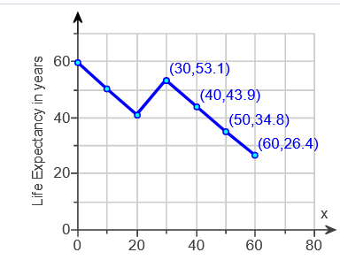

Let x be:



Let y be:

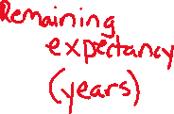

The graph contains the points . The slope between these 2 points is:

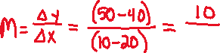

**In context**, this tells us that remaining life expectancy ______________ between the ages 10 and 20 by 1 year for each year of life. The RISE/FALL or change in y is remaining life expectancy, the RUN or change in x is age.



*Example #1* – Interpret Slope as a Rate Change



a) Use the data in the graph above to find the average rate of change of life expectancy between ages 20 and 30.

This is asking to find the slope between the points

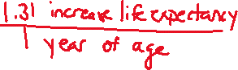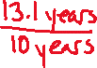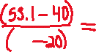

**In context,** this tells us:



*Example #2* – Build a Linear Model using Slope as a Rate of Change

a) In 1950 Americans spent 3% of their budget on health care. This has increased by approximately 0.22% per year since then. Build a linear model that models total percentage spent on health care years after 1950.

Let x be:



Let be:



Slope is a **rate**, which is:



The -intercept is:



We can use this information to write a model in slope-intercept form:



Use the model to predict the percentage of their budgets that Americans will spend on health care in 2024 (this is how many years after 1950?):



*YOU TRY #3* – Let *x* represent a year and *y* represent the number of women living alone in that year.

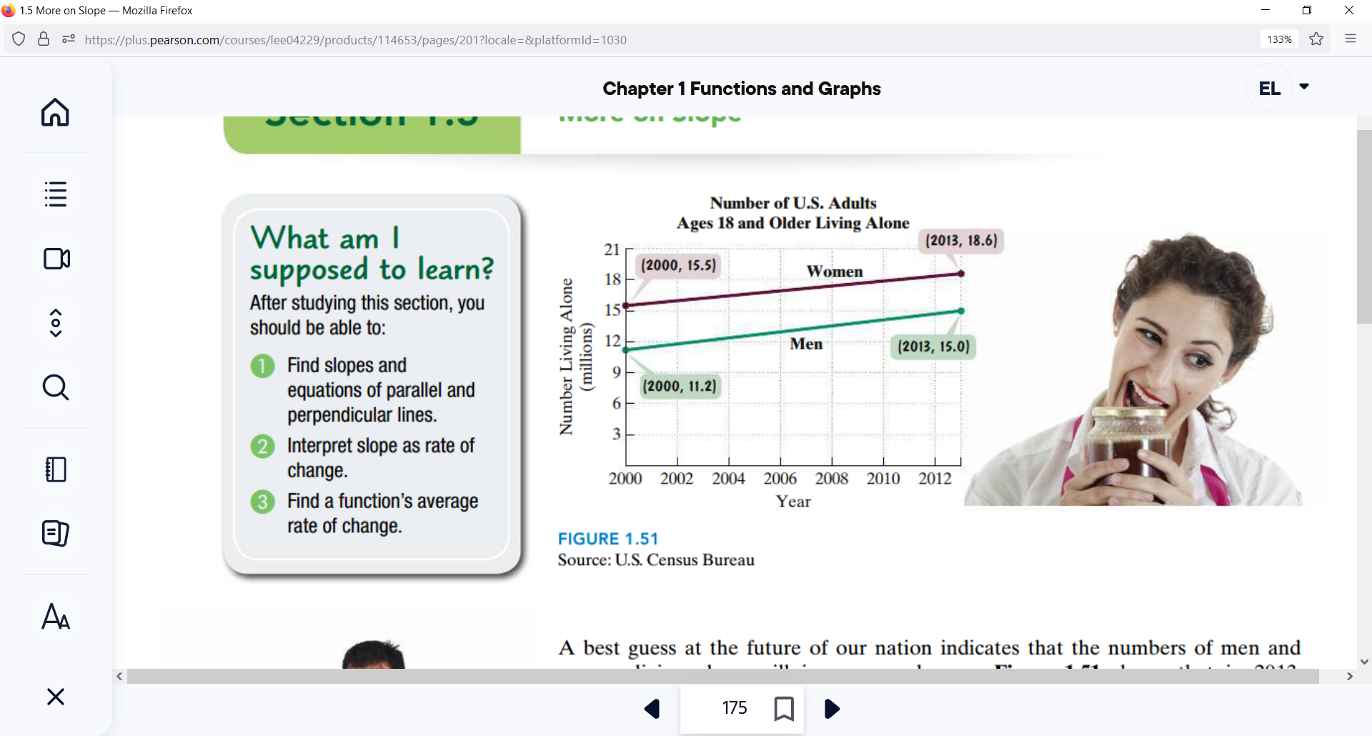

Let x be:



Let be:



a) In the context of the problem, interpret the point (2013, 18.6) in a complete sentence.



b) Use the ordered pairs in the figure above to find the slope of the green line segment for the men. Express the slope correct to two decimal places and describe in a complete sentence what it represents.

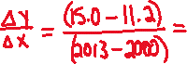

*YOU TRY #4* – Build a Linear Model using Slope as a Rate of Change

In 1950 Americans spent 22% of their budget on groceries. This has decreased approximately 0.25% per year since then. Build a linear model that models total percentage spent on groceries care years after 1950.



Let x be:



Let be:



Use the model to predict the percentage of their budgets that Americans will spend on groceries in 2024 (this is how many years after 1950?):



# Topic #4: The Average Rate of Change for a Function (abbreviated AROC)

If the graph of a function is_______________________, the AVERAGE RATE OF CHANGE between any two points is the slope of the line containing two points.



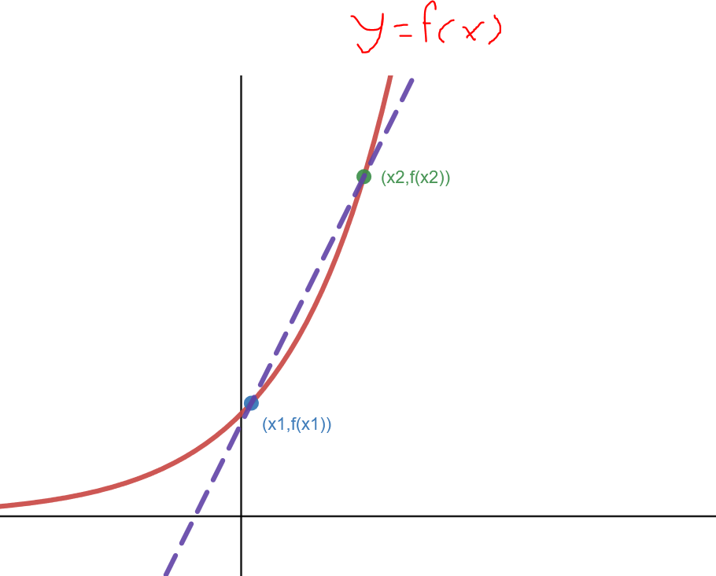

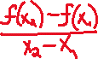

The line that connects the points is called a ___________________ and its slope is the average rate of change between the 2 points.



The AVERAGE RATE OF CHANGE between the points is the SLOPE between the points:

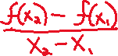

_________________ are unique in that the average rate of change between any 2 points is a constant (the slope of the line).



*Example #1* – Find the Average Rate of Change between the Points on the Function



a)



Plug in the values to get the values;



You can also write these as ordered pairs:



Now find the slope:

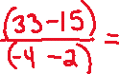

Since the function is linear with a slope of 8, we KNOW the average rate of change between ANY 2 points is also 8! **The secant line is the actual line in this case.**



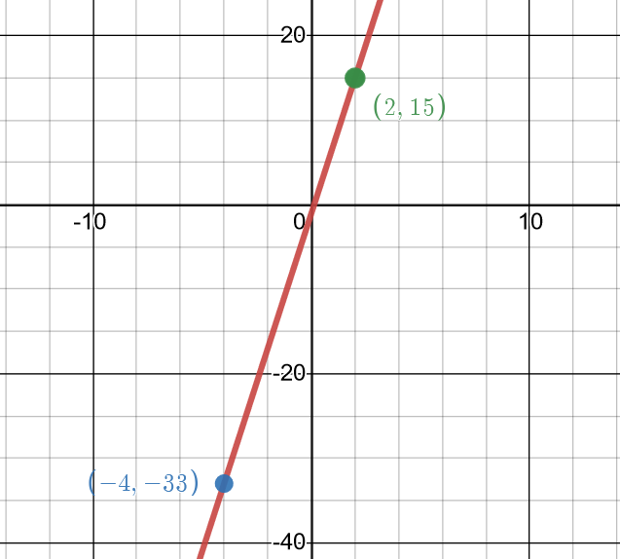

b)



This is non-linear, so we evaluate the function and use the definition. Plug in the values to get the

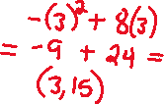

=

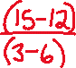

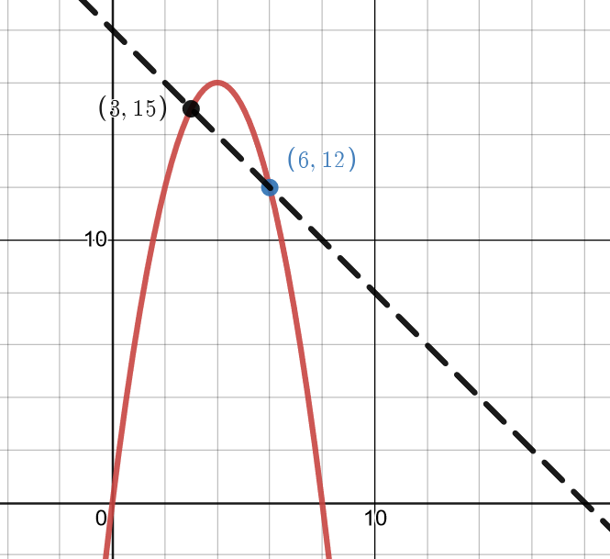



The secant line shows an average ________________ between the 2 points.



*YOU TRY #5*

This is non-linear, so we evaluate the function and use the definition. Plug in the values to get the values;

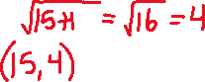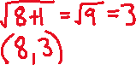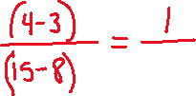

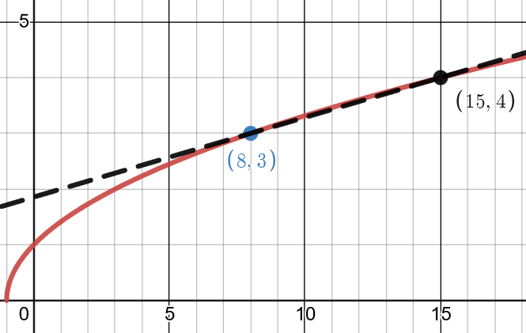

The secant line shows an average____________ between the 2 points.



*YOU TRY #6* – Find the Average Rate of Change between the Points on the Function in Context

The age (in years) and expected length (in inches) of certain species of fish is modeled by the function:

where is the length in inches and is the age in years.

Let x be:

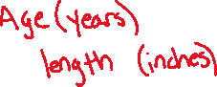

Let be:

1. What is the expected length of a 10-year old fish?

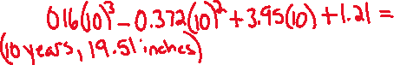

1. What is the expected length of a 15-year old fish?

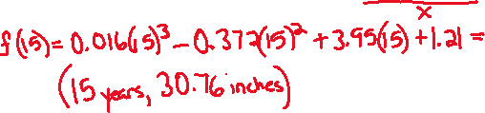

c) What is the average rate of change in expected length over this time-period? Include units. Interpret your answer in a sentence.

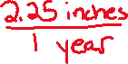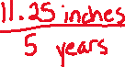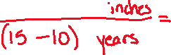

**Topic #5: The Difference Quotient**

The Difference Quotient is used to find the average rate of change between any 2 points of a function. We will define this as SLOPE, but look at the Difference Quotient here. Consider the function and its 2 values at and (which is just another point units away from the initial point):



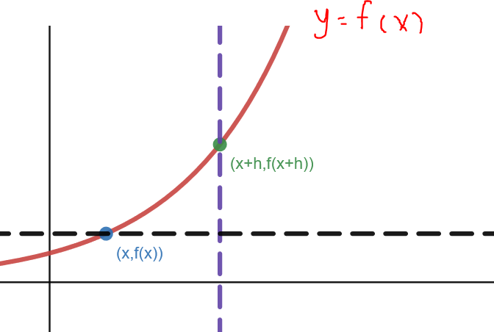

The average rate of change between the points is the change along the -axis over the change along the -axis:

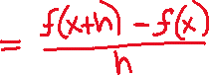

The denominator simplifies and the result is the definition of the Difference Quotient:

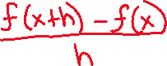

For example, consider the function:

To find the Difference Quotient, we need



Next, we use the definition above and simplify:

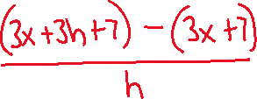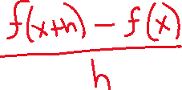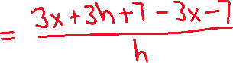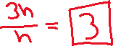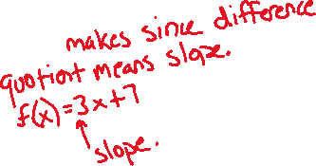

The function above is linear and the slope of the line is the average rate of change between any 2 points, which in this case is a slope of 3.

*Example #1* – Construct and Simplify the Difference Quotient for the Given Function

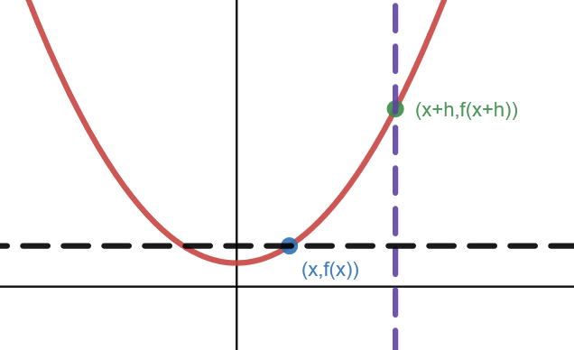

We start by simplifying

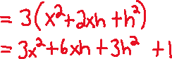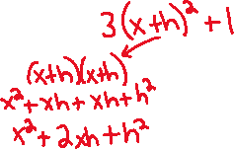

Then we use the definition and simplify

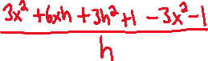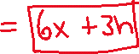

*YOU TRY #4* - Construct and Simplify the Difference Quotient for the Given Function

Start by finding ; remember, substitute x + h for x everywhere in the function and simplify:



Then use the definition and simplify:

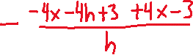

*YOU TRY#5* - Construct and Simplify the Difference Quotient for the Given Function

We start by simplifying

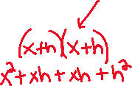

Then we use the definition and simplify

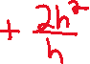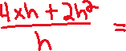

*YOU TRY#6* - Construct and Simplify the Difference Quotient for the Given Function

6

We start by simplifying



Then we use the definition and simplify



The function above is a horizontal line and all horizontal lines have a slope of 0.

